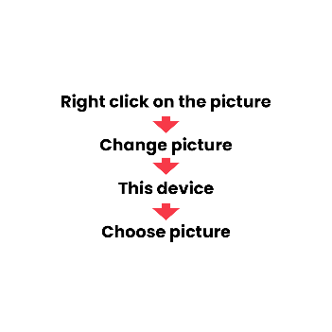

**FIRST NAME LAST NAME**

Head of XY

PROFessional experience

Feb 2022 - today Head of XY   
*Company AG*

* Describe your tasks and responsibilities
* Describe your tasks and responsibilities
* Describe your tasks and responsibilities

Jul 2013 – Mar 2022 Consultant  
*Company GmbH*

* Describe your tasks and responsibilities
* Describe your tasks and responsibilities
* Describe your tasks and responsibilities

education

Jul 2009 - Jun 2011 Master in XY   
*University of Bern*

* European Business & Organization and Human Resource Management
* Thesis in xy: « Lorem Ipsum » (Mark: 5.25)

Jul 2004 – Jun 2008 Bachelor in XY   
*University of Bern*

* European Business & Organization and Human Resource Management
* Thesis in xy: « Lorem Ipsum » (Mark: 5.25)

PERSONAL INFORMATION

27.07.1989

Beispielstrasse 12

Postal Code City

+41 78 888 88 88

[Firstname.lastname@mail.com](mailto:Firstname.lastname@mail.com)

LANGUAGE SKILLS

English (Native)

French (C1)

German (B2)

SKILLS

MS Excel

MS Word

MS Powerpoint

PERSONAL INTERESTS

Photography

Climbing

Cinema

Video games

Ju-Jitsu